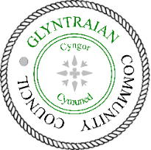
Cyngor Cymuned Glyntraian Community Council
Agenda for Glyntraian Community Council Meeting 5th April 2023

MEMBERS OF THE PUBLIC AND PRESS ARE WELCOME TO ATTEND THE MEETING

1. Apologies
To receive apologies and reasons for absence

2. Declaration of Interests and Dispensations
(a) to record any declarations of interest in items on the agenda
(b) to consider any requests for dispensations

3. Reports
- To receive the Police report

- To receive a report from Wrexham County Borough Councillor Trevor Bates

4. Minutes of the last Meeting (1st March 2023)
(a) To approve and sign the minutes of last meeting (1st March 2023)
(b) Matters Arising

5. Correspondence
To record and review any correspondence received

6. Community Agent
To receive the Community Agent report

7. Finance
(a) To review the summary finance report
(b) To authorise and sign payments
(c) To authorise the Council’s Reserve Policy
(d) To review s137 donation application from the Ceiriog Valley Garden Society

8. Celebrations for King’s Coronation
To review Coronation Committee’s ideas for an event to celebrate the King’s Coronation

9. Planning
To review planning application P/2023/0086 (Bedlwyn, Bedlwyn Road, Llwynmawr - single storey rear extension

10. Environment Committee
To review the Ceiriog River Survey

11. Oliver Jones Memorial Hall
To review kitchen facilities at the Oliver Jones Memorial Hall

12. Agenda Items for Next Meeting
To agree agenda items for the next Council meeting (3rd May 2023)

Signed:
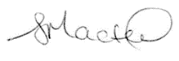
Stephanie Masters CiLCA
Clerk/Clerc - Cyngor Cymuned Glyntraian Community Council
Dated 30th March 2023
Email: clerk@glyntraian.org.uk
Phone: 07535733418

